<<COURT_NAME>>

|  |  |
| --- | --- |
| <<PROVIDER_SUITNAME>>,  a/a/o <<INJUREDPARTY_NAME>>    Plaintiff,  vs.  <<INSURANCECOMPANY_SUITNAME>>  Defendant. | Case No. <<INDEXORAAA_NUMBER>> |

__________________________________________/

**STANDBY TRIAL SUBPOENA DUCES TECUM FOR TRIAL**

TO: <<INJUREDPARTY_NAME>>

<<INJUREDPARTY_FULL_ADDRESS>>

YOU ARE HEREBY COMMANDED to appearto give testimony at the trial in the above-captioned cause for the trial period beginning on **November 29, 2021 at 8:30 AM** at the Bay County Courthouse, 300 E 4th St, Panama City, FL 32401. **This subpoena is valid from November 29, 2021 to December 3, 2021.**

**THIS CASE IS CURRENTLY ON STANDBY FOR TRIAL. CONTACT THE UNDERSIGNED ON NOVEMBER 29, 2021 TO CONFIRM IF TRIAL WILL GO FORWARD ON THE ABOVE REFERENCED DATE.**

**IF YOU FAIL TO APPEAR, YOU MAY BE IN CONTEMPT OF COURT.**

You are subpoenaed to appear by the following attorneys and unless excused from this subpoena by these attorneys or the Court you shall respond to this subpoena as directed.

Dated: February 20, 2022

**The Florida Insurance Law Group, LLC**

8724 Sunset Drive, #260, Miami, FL 33173

Tel. (305) 906-4262

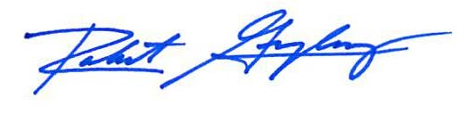

Robert F. Gonzalez, Esq.

[Pleadings@flinslaw.com](mailto:Pleadings@flinslaw.com)

Fla. Bar No. 68865